What is human development index
The human development index is is a summary of human progress in long terms. Its is divided into 2 parts. Firstly they analyze the human life expectancy starting from the past to the present. Secondely the school years exepectancy this means how many years of schooling do people have in madagascar starting from the past to the present.
Madagascar is clearly a led’c because its human development index is very low. For 2012 is 0.483. and this ranks Madagascar 151 out of 187 countries/territories Madagascar’s HDI has increases around 13% from 2000 – 2012 this means an annual increase of 1.0%
Below comes a table showing HDI in details and what caused that 1% increase annually
 | Life expectancy at birth | Expected years of schooling | Mean years of schooling | HDI value
1980 | 48.2 | 8
1985 | 49.3 | 8.1
1990 | 50.7 | 6.6
1995 | 54.9 | 6.6
2000 | 59.7 | 6.6 | 5.2 | 0.428
2005 | 64.1 | 9.3 | 5.2 | 0.467
2010 | 66.5 | 10.4 | 5.2 | 0.484
2011 | 66.7 | 10.4 | 5.2 | 0.483
2012 | 66.9 | 10.4 | 5.2 | 0.483
￼
below is a line graph. More attractive ;)

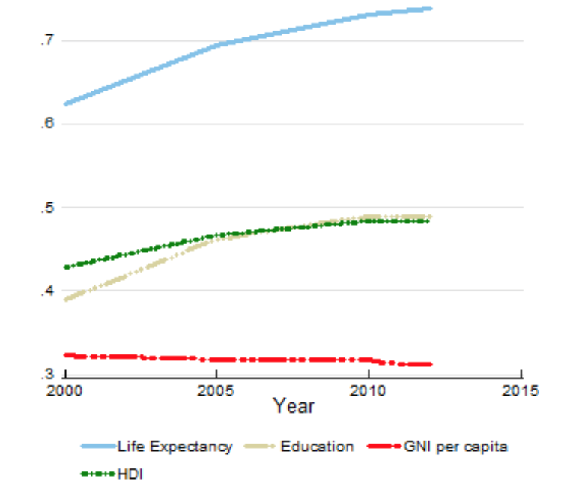
Madagascar is one of the poorest countries in the world with a population growing faster than its economy. Over 11 million people do not have access to safe water.

Only 66% of Madagascar’s people have clean water in their houses and 15% do not have access to that drinkable water . It is said to be that the citizens spend 3 hours to collect and that water is not even safe. Most people die from diseases due to the unsafe water. If there was minimum conditions for water people would have more free time and have a better life

